EENG 385 - Electronic Devices and Circuits

Frequency Domain: Active Filters

How To: Audio Board Interface

**How To: Audio Board Interface**

The audio board was designed with the low-pass filter (LPF), band-pass filter (BPF), high-pass filter (HPF) and a level-shifter (LEVEL). The schematics for these four circuits are shown in Figure 1.

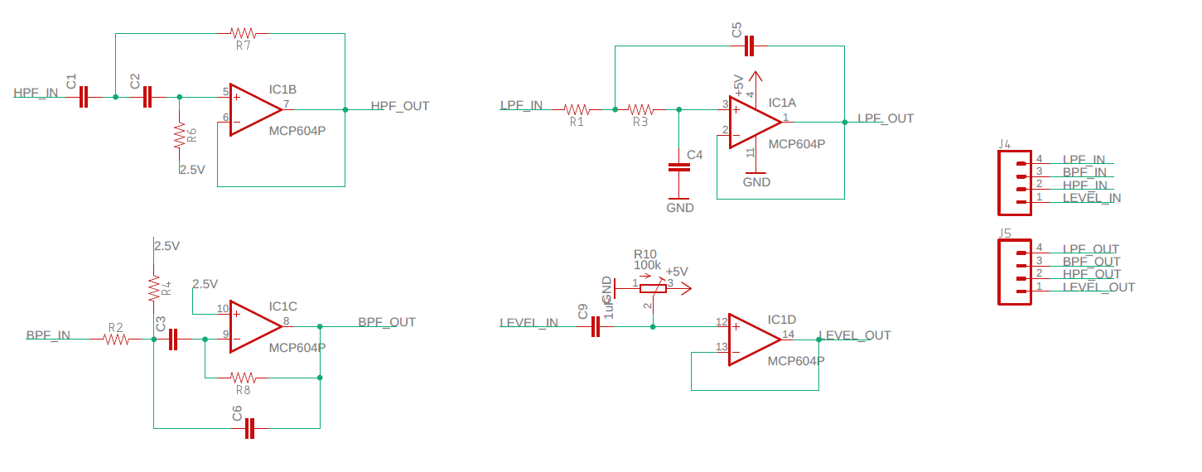

Figure : These are the three filters and level shifter on the audio board.

These four circuits are laid out around the MCP6004 opamp, all the components associated with each circuit are contained in an outlined area containing the name of the circuit shown in Figure 2.

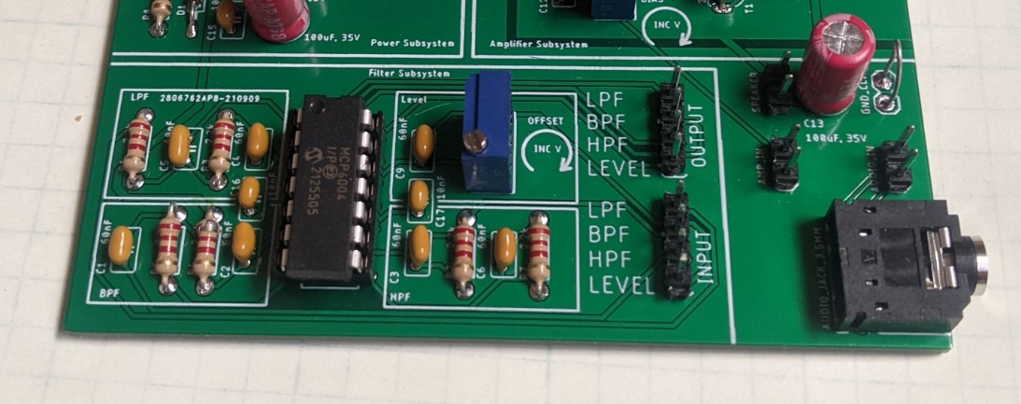

Figure : The filter subsystem allows you to experiment with different filters.

Each of the circuits has its input and output available on a 4-pin header. Note that the input header is below the output header – some PCBs lack the text “INPUT” and “OUTPUT”. It’s important to note that all four of these circuits are independent of one another.

The circuits were designed so that you could connect them in series. For example, let’s say that you wanted to connect the level shifter and low pass filter in series as shown in Figure 3.

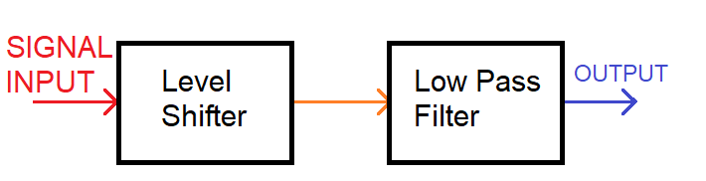

Figure : An example configuration for the circuits.

To do this you would connect the SIGNAL INPUT to the LEVEL INPUT header pin. Then you would connect the LEVEL OUTPUT header pin to the LPF INPUT header pin using a piece of jumper wire. The OUTPUT signal would then be available at the LPF OUTPUT pin. This arrangement is shown in Figure 4.

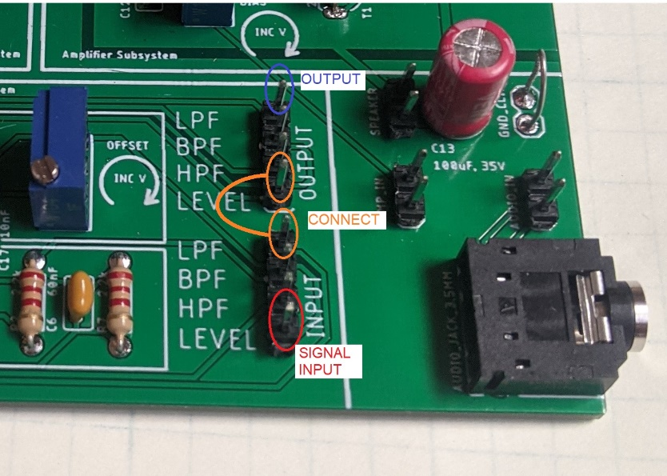

Figure : Connection of headers to combine the level shifter and low pass filter in series.

You will need to series combination in order to draw a Bode plot using the FRA function of our Keysight Infinivision oscilloscopes.

The real reason that the board is designed with these headers is to allow a user to run an audio signal through a filter and then amplify it and listen the effect. You can even cascade several filters together by connecting one filter output to another filter output. I think that hearing the effect of a filter on an audio signal helps develop a visceral understanding of filter behavior.